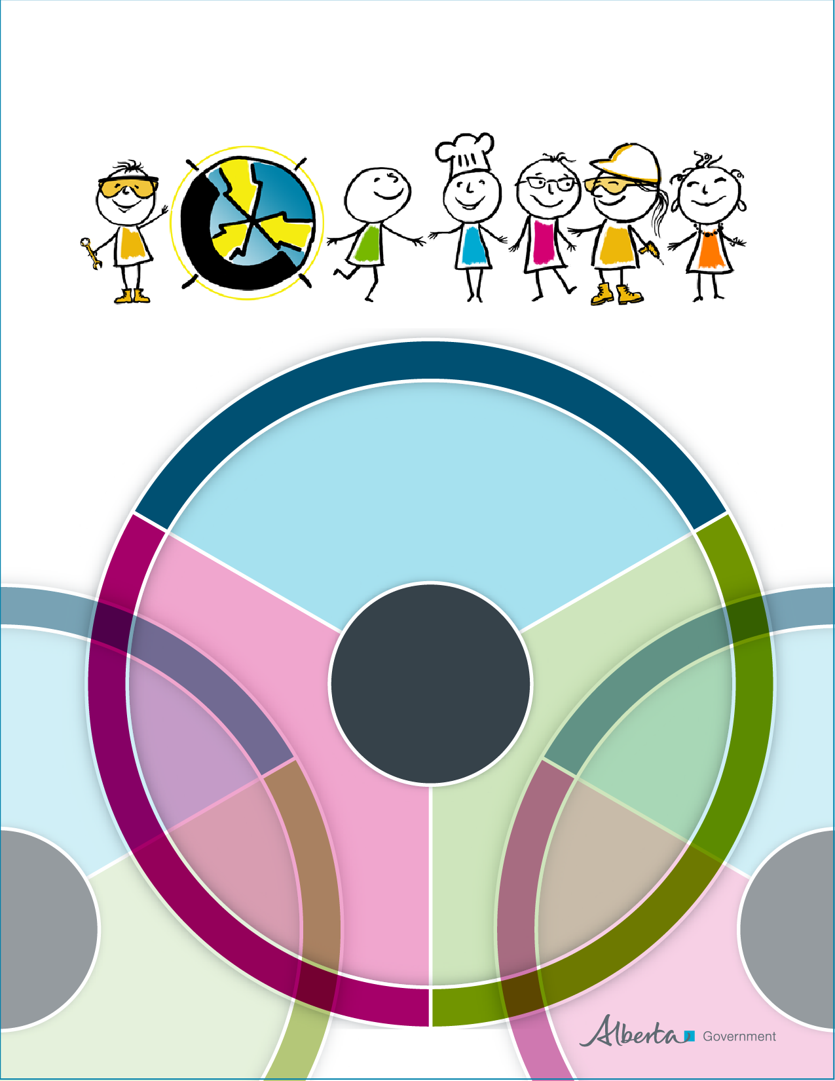
CTF Classroom Assessment Tool
CTF Classroom Assessment Tool
Alberta Education developed a CTF classroom assessment tool for each learning outcome. The tool supports the understanding that not all students learn the same way and at the same pace. The tool serves a number of purposes, including:
- assess student achievement of learning outcomes
- provide behaviour descriptors
- personalize assessment
- differentiate instruction
- plan effective learning activities
- guide teacher developed assessments
- determine a student’s background knowledge and skills
- identify student strengths
- determine a student’s next learning steps

CTF learning outcomes are the same for grades 5 through 9. The outcomes
- provide the expectations for student learning
- describe what a student should know or realistically be able to do by the end of a CTF task, challenge, class or course
- identify how students will be able to apply and integrate their knowledge and skills

How learning outcomes are taught and assessed is the professional responsibility of the teacher.

The CTF classroom assessment tool for each learning outcome provides behaviour descriptors grouped according to three stages. Behaviour descriptors are suggestions for how students can demonstrate the understanding and skills associated with each learning outcome. The three stages are acquire, apply and adapt. Behaviour descriptors and stages
- provide the opportunity to differentiate instruction and personalize assessment
- recognize that students bring their own experiences, skills and prior knowledge to a learning experience
- depend upon the complexity of the task or challenge
- can vary from one challenge, occupational area or grade level to another
- offer different entry points for students to participate in the learning process

Selecting the appropriate behaviour descriptor and stage for a student or group of students is important. The behaviour descriptor can represent an entry point or an end goal. Students’ current knowledge and skills, their strengths and the next steps in their learning are important in identifying entry points. Choosing a behaviour descriptor or stage should
- involve students
- establish students’ prior knowledge
- focus on what a student can do, clearly identifying both strengths and areas for growth
- identify next steps for further learning

The general descriptions for the three stages are:
Stages | General Description
Acquire | Construct meaning and understanding of the requirements of a learning outcome.
Apply | Demonstrate and practise knowledge and skills associated with a learning outcome.
Adapt | Analyze, assess, reflect on, integrate or modify knowledge and skills associated with a learning outcome.

CTF Classroom Assessment Tool
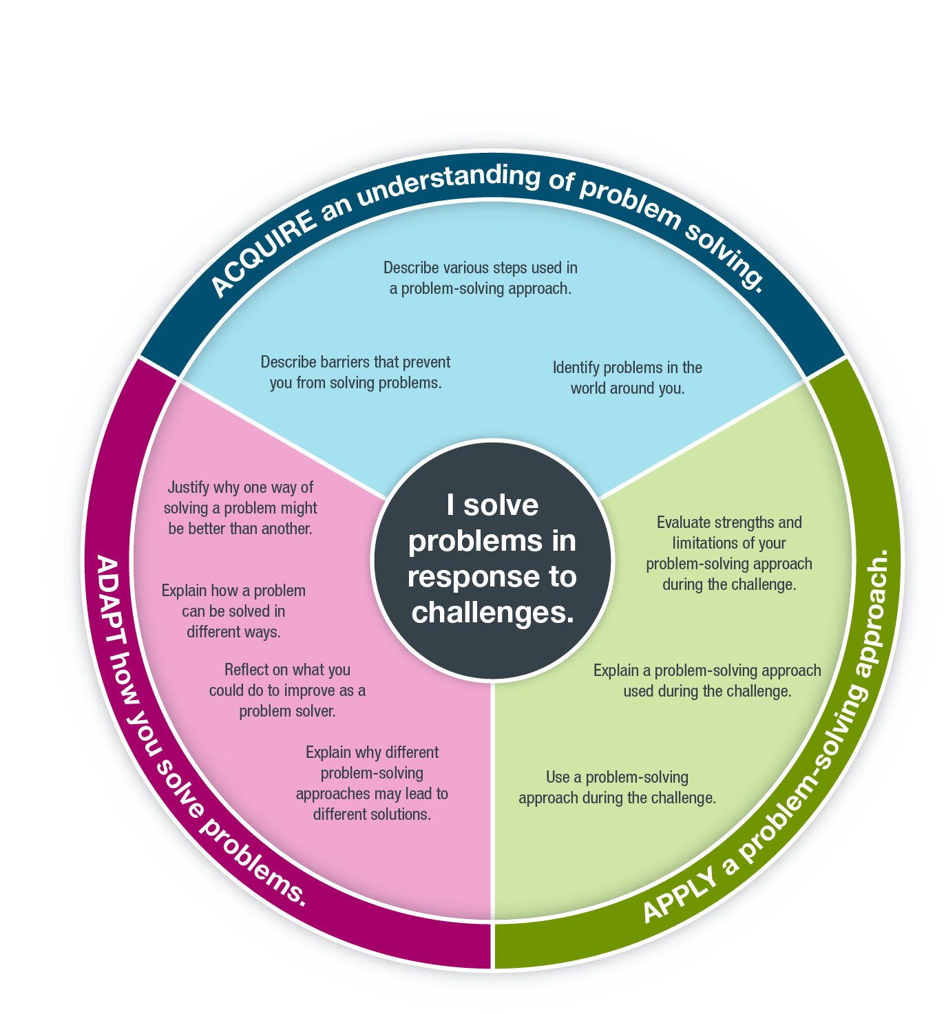
CTF Learning Outcome
CTF Behaviour Descriptors
CTF Stages

You may use this pre-populated tool or customize it with your own text.

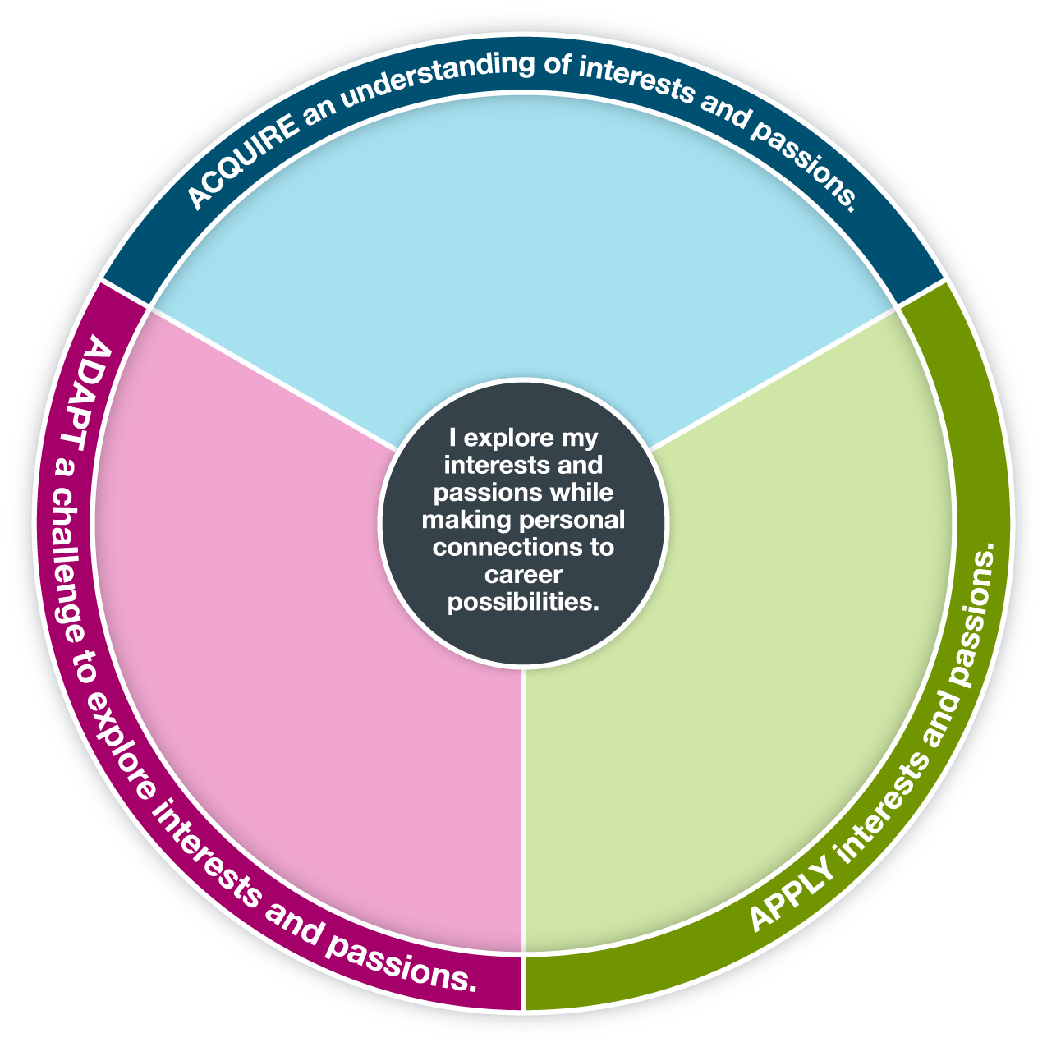
Determine how the challenge influences your interests and passions.
Explain ways that you explore your interests and passions through the challenge.
Identify connections between your interests and passions and the occupational areas of the challenge.
Modify the challenge to allow you to explore your interests and passions.
Explain why understanding your interests and passions is useful.
Create a challenge that allows you to explore your interests and passions.
Identify your interests and passions.
Discuss interests and passions that people have.

You may use this pre-populated tool or customize it with your own text.
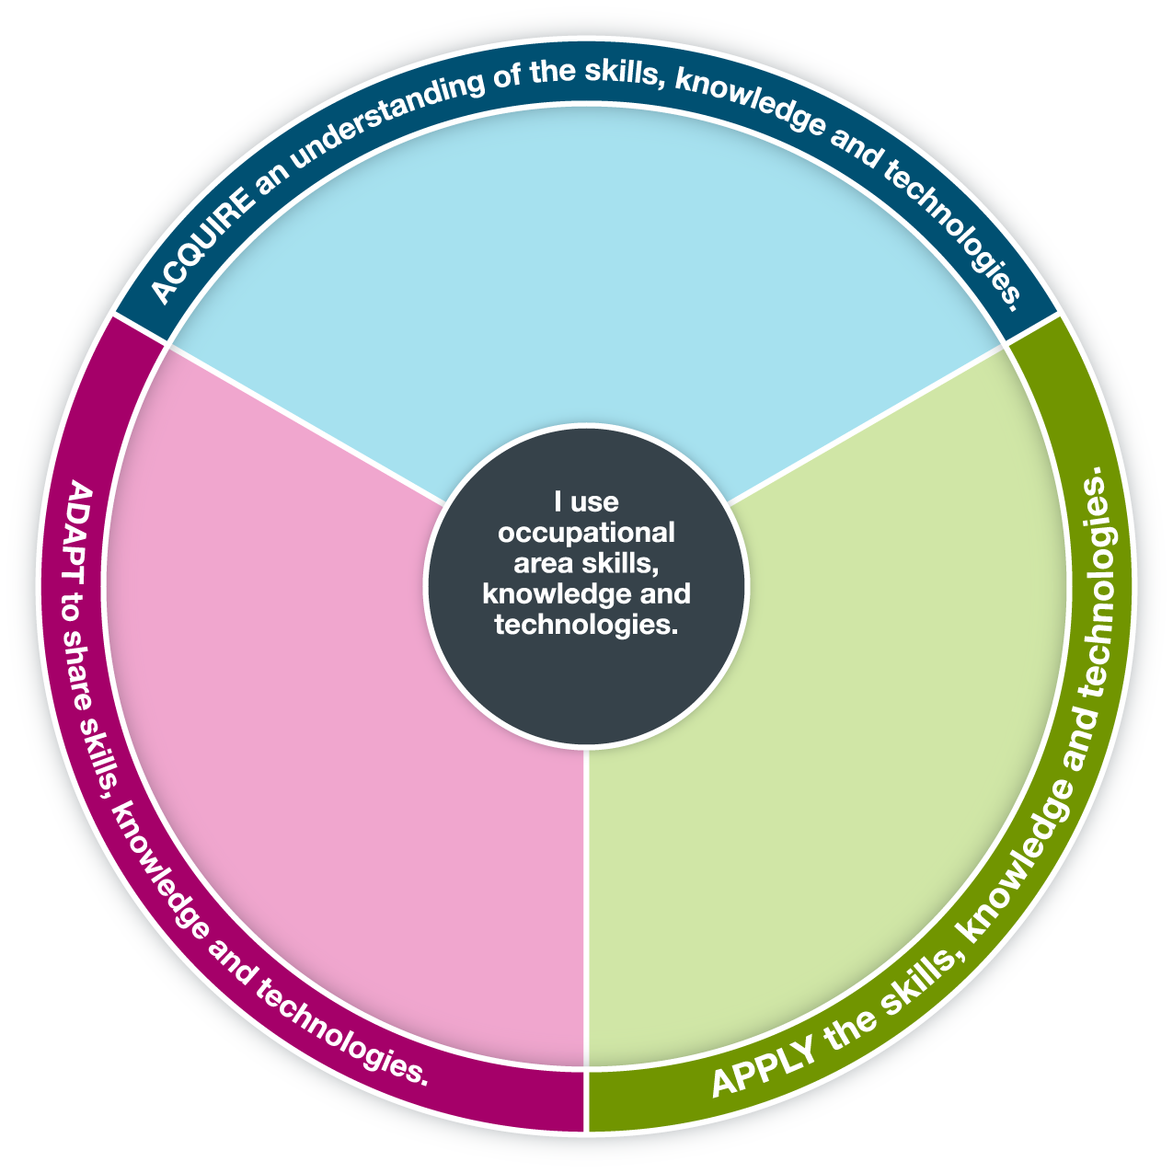
Explain to others the skills, knowledge and technologies related to this challenge.
Discuss skills, knowledge and technologies that exist in the world around you.
Identify what you will need to do to acquire the skills and knowledge and use the technologies necessary to be successful in the challenge.
Determine specific skills, knowledge and technologies required for the challenge.
Practise the skills, knowledge and technologies required by the challenge.
Provide feedback as others develop skills, knowledge and technologies related to this challenge.
Demonstrate proficiency with the skills, knowledge and technologies required by the challenge.
Mentor others who are developing skills, knowledge and technologies related to this challenge.

You may use this pre-populated tool or customize it with your own text.
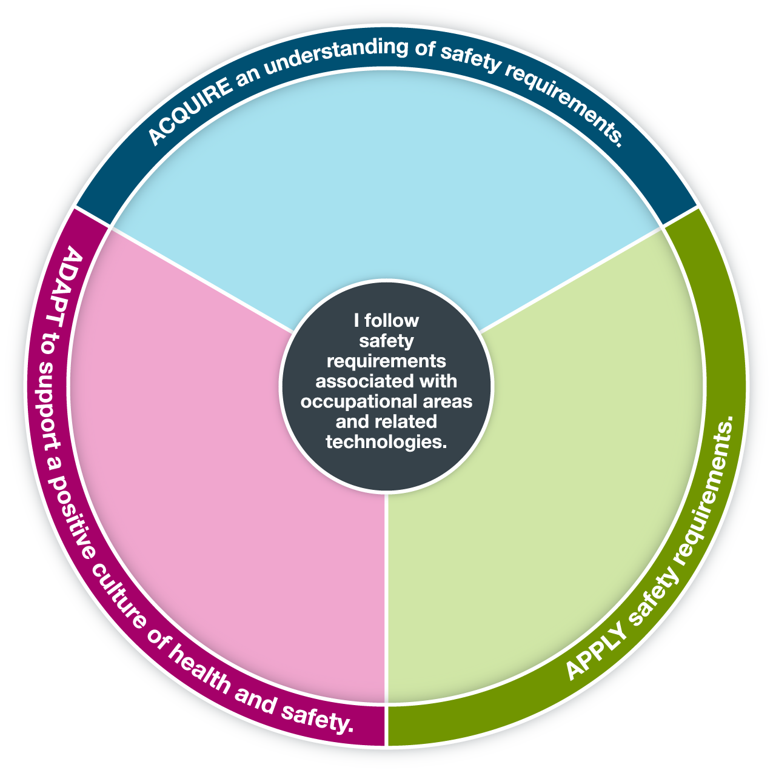
Explain characteristics of a positive health and safety environment.
Identify the specific safety requirements of the challenge.
Follow the safety requirements of the challenge.
Support others in following safety requirements.
Promote a culture of health and safety.
Explain the importance of being safe.
Discuss what you do to be safe.

You may use this pre-populated tool or customize it with your own text.

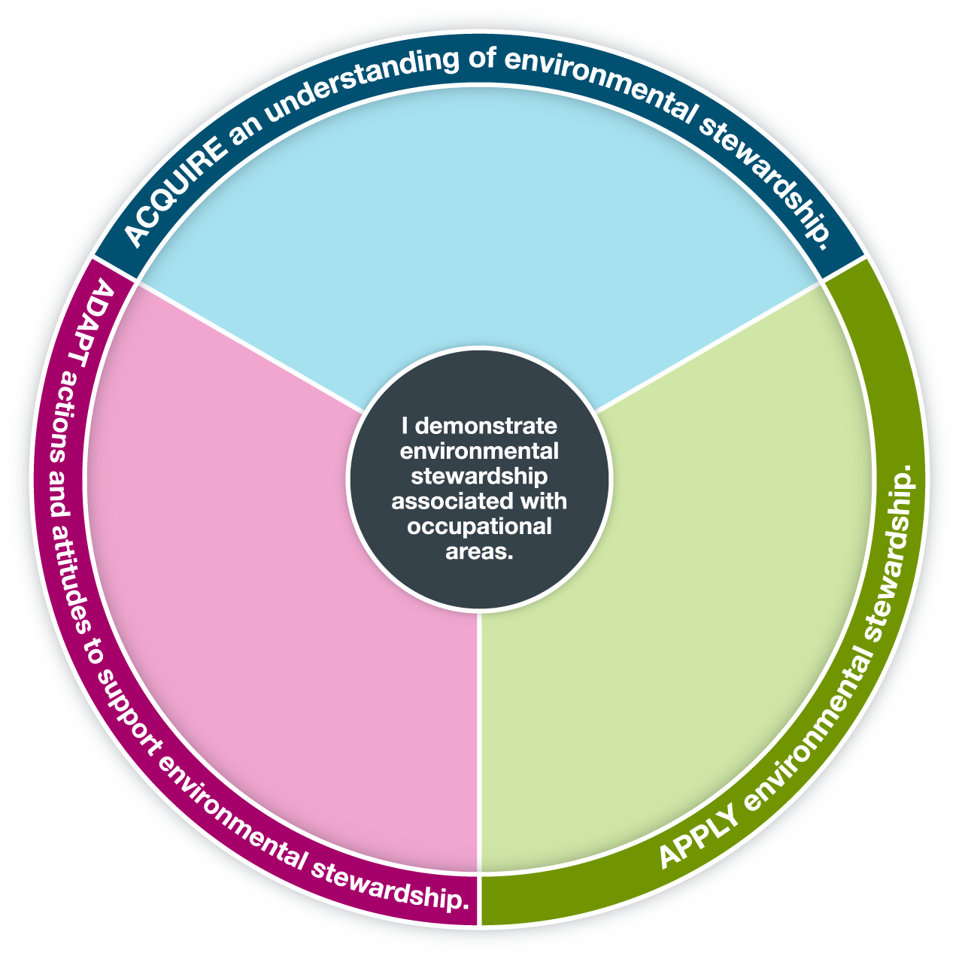
Discuss how the challenge influences the choices you make to support environmental stewardship.
Promote the idea that environmental stewardship is a form of civic responsibility.
Demonstrate environmental stewardship during the challenge.
Propose improvements to the challenge that promote the well-being of the environment.
Identify potential environmental concerns in the challenge in order to practise good environmental stewardship.
Identify diverse cultural perspectives regarding environmental stewardship.
Discuss what being environmentally friendly looks like.

You may use this pre-populated tool or customize it with your own text.

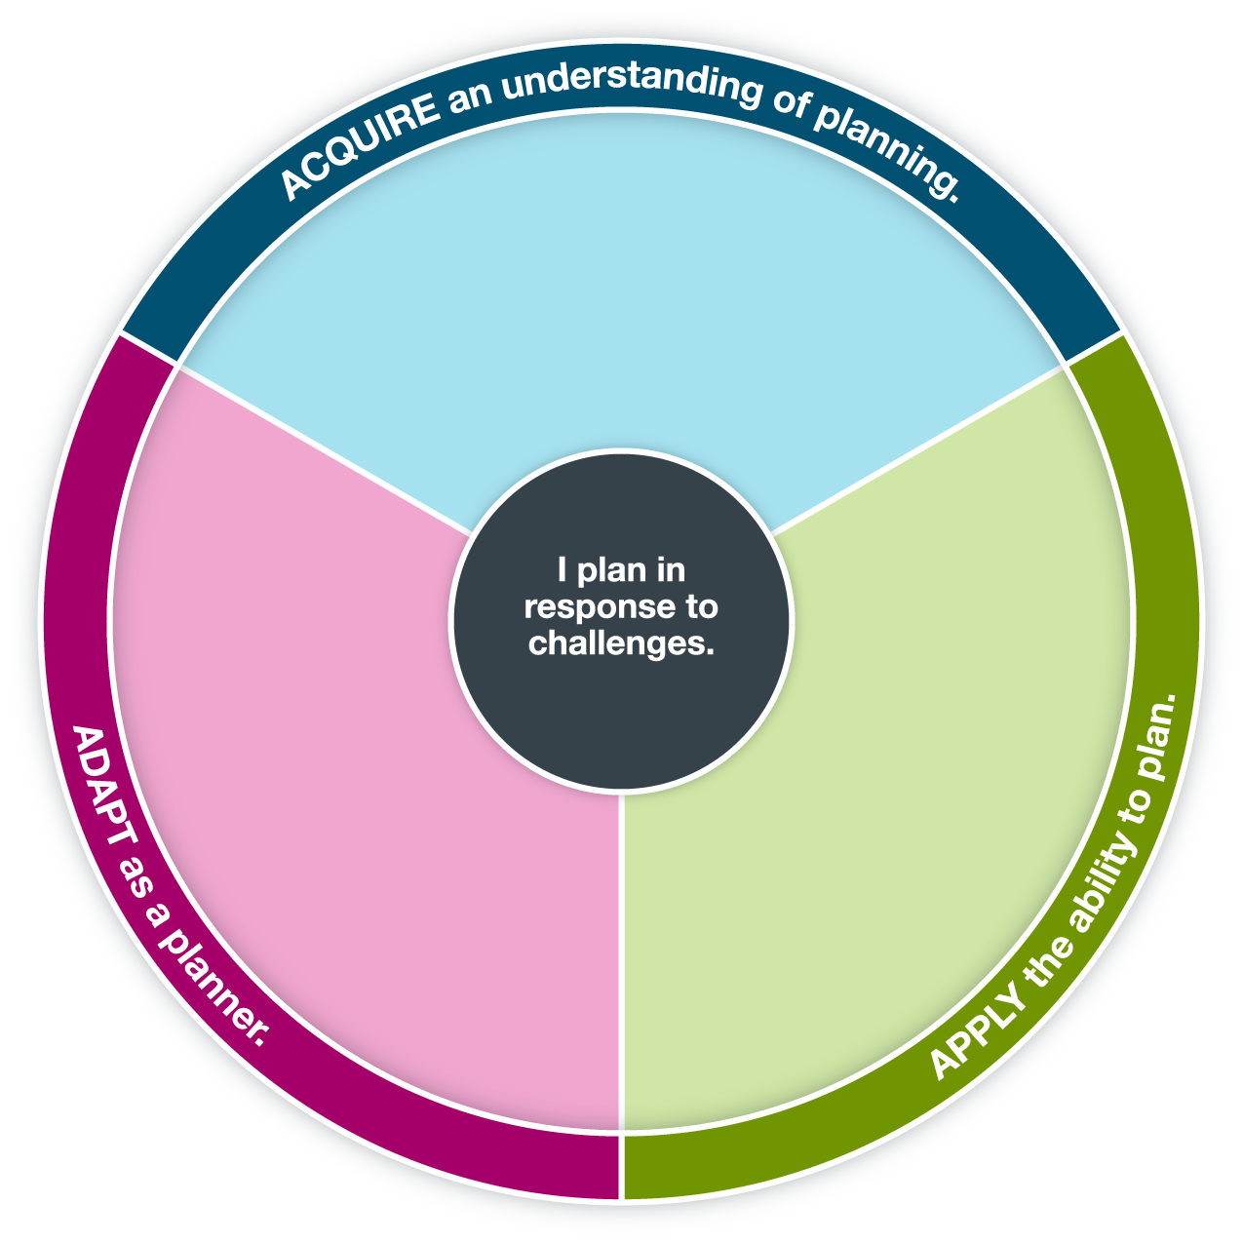
Follow the plan as you work through
the challenge.
Revise the plan as required throughout the challenge.
Evaluate the strengths and limitations of the plan.
Create a plan to address the challenge.
Identify what you have to think about when planning.
Describe how planning is used in the world around you.
Explain why planning is helpful.

You may use this pre-populated tool or customize it with your own text.

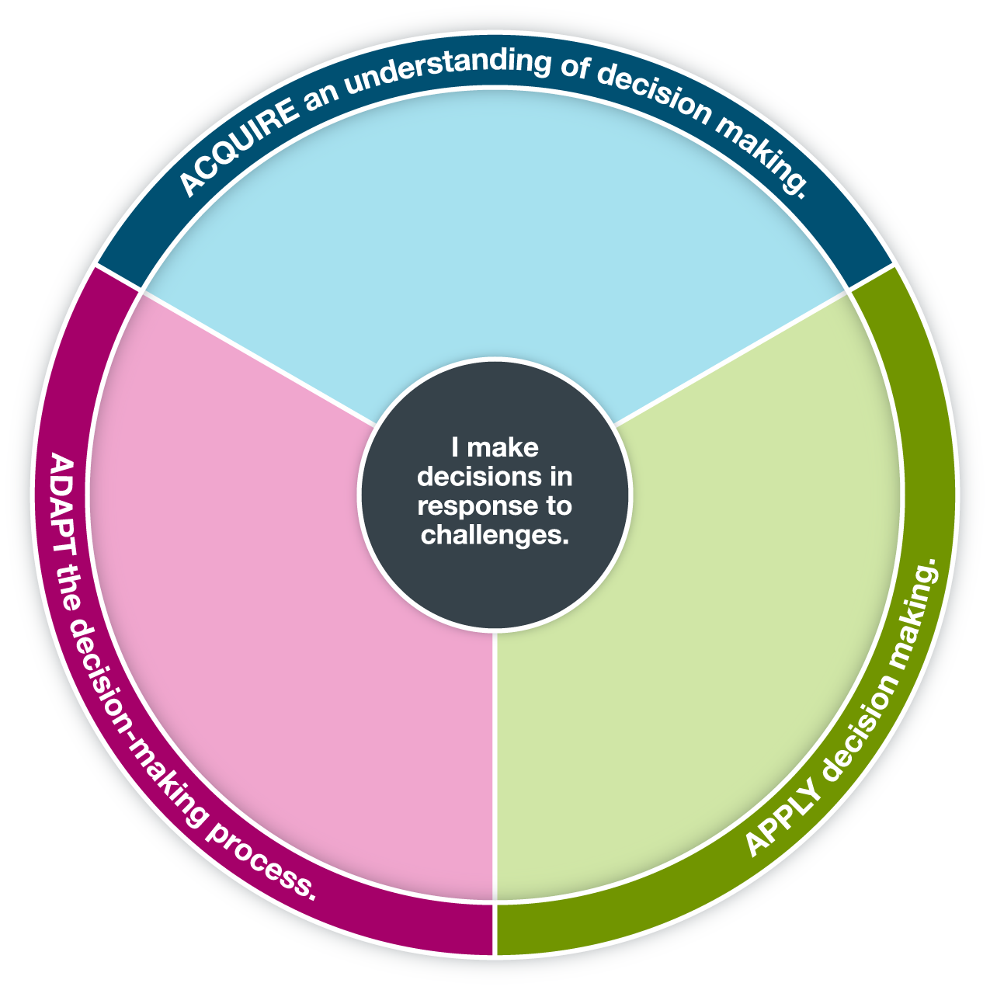
Discuss the effectiveness of your current
decision-making process.
Reflect on your ability to use a new way of making decisions.
Identify decisions made during the challenge that you would change and the reasons for the changes.
Identify decisions involved with the challenge.
Describe how you make decisions during the challenge.
Explain why you make the decisions you do during the challenge.
Explain why making decisions is sometimes tough.
Identify why it’s important to make decisions.
Discuss how you feel when you have to make decisions.

You may use this pre-populated tool or customize it with your own text.

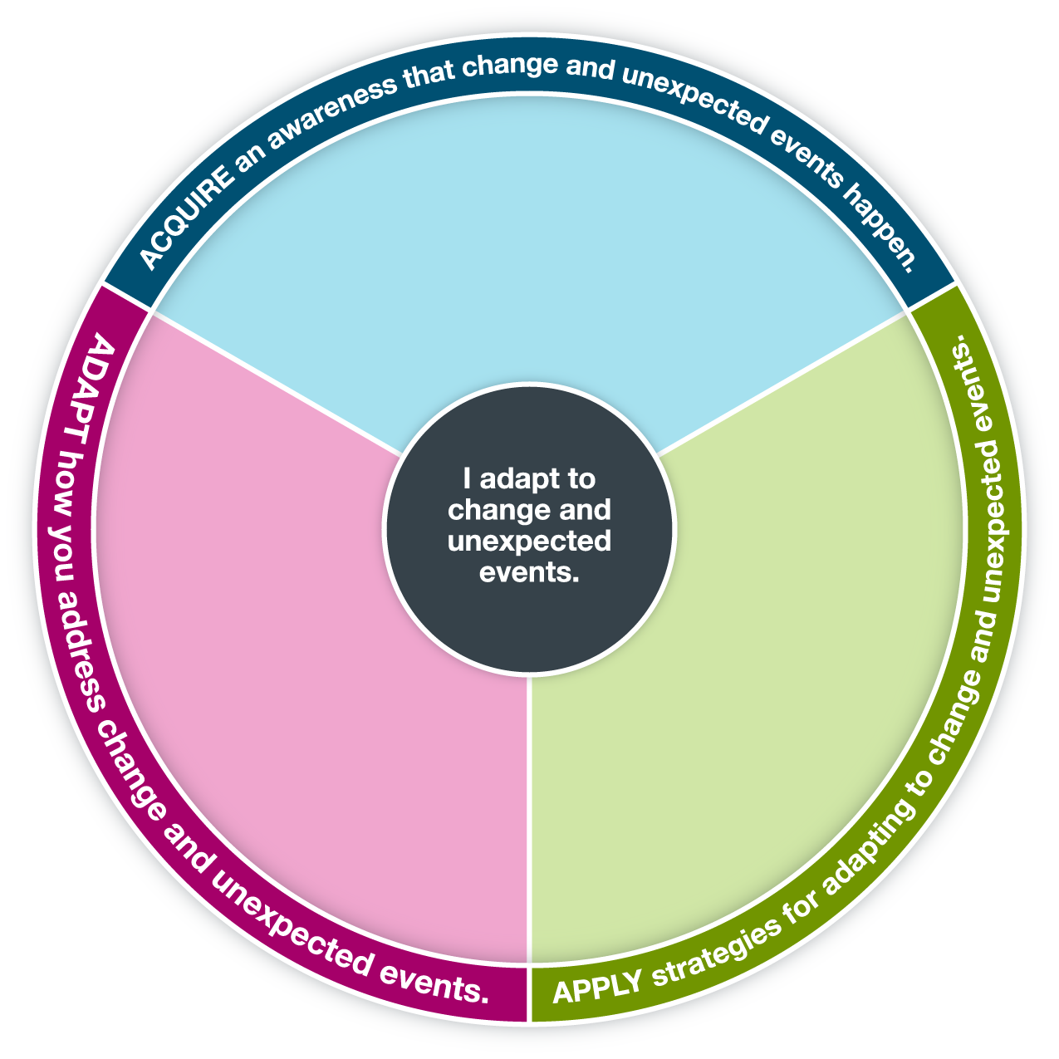
Evaluate the effectiveness of strategies used to adapt to change and unexpected events during the challenge.
Describe a time when you have dealt with change and unexpected events.
Identify strategies used for handling change and unexpected events.
Reflect on your ability to adapt to change and unexpected events.
Identify implications of not adapting to change and unexpected events.
Assist others who are learning to adapt to change and unexpected events.
Use strategies to adapt to change and unexpected events during the challenge.
Discuss how you handle change and unexpected events.

You may use this pre-populated tool or customize it with your own text.

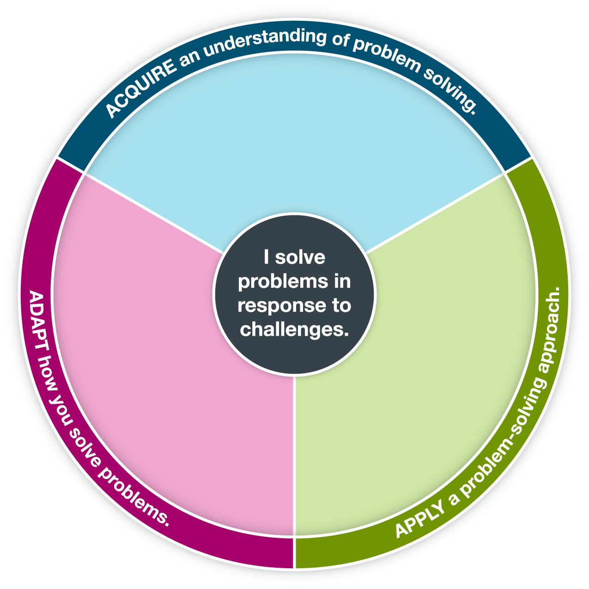
Use a problem-solving approach during
the challenge.
Evaluate strengths and limitations of your problem-solving approach during
the challenge.
Explain why different problem-solving approaches may lead to different solutions.
Justify why one way of solving a problem might be better than another.
Explain how a problem can be solved in different ways.
Reflect on what you could do to improve as a problem solver.
Explain a problem-solving approach used during the challenge.
Describe barriers that prevent you from solving problems.
Identify problems in the world around you.
Describe various steps used in a problem-solving approach.

You may use this pre-populated tool or customize it with your own text.

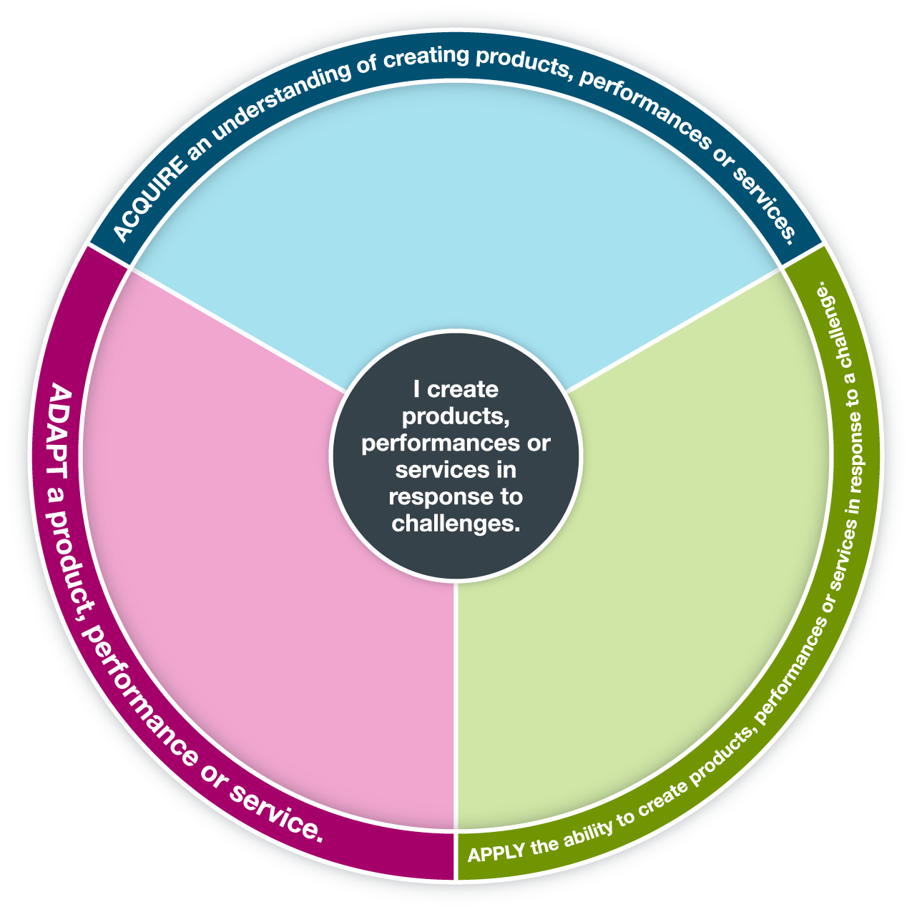
Identify the “Need to Knows” that you must address to successfully complete the challenge.
Experiment with a variety of processes to create a product, performance or service that responds to the challenge.
Seek feedback to improve your product, performance or service.
Demonstrate risk taking or perseverance in creating a product, performance or service.
Justify changes that you make as you develop your product, performance or service.
Justify how your product, performance or service meets the needs of the challenge.
Generate ideas for products, performances or services to respond to the challenge.
Monitor the development of a product, performance or service that you create in response to the challenge.
Identify the purpose of the challenge.

You may use this pre-populated tool or customize it with your own text.

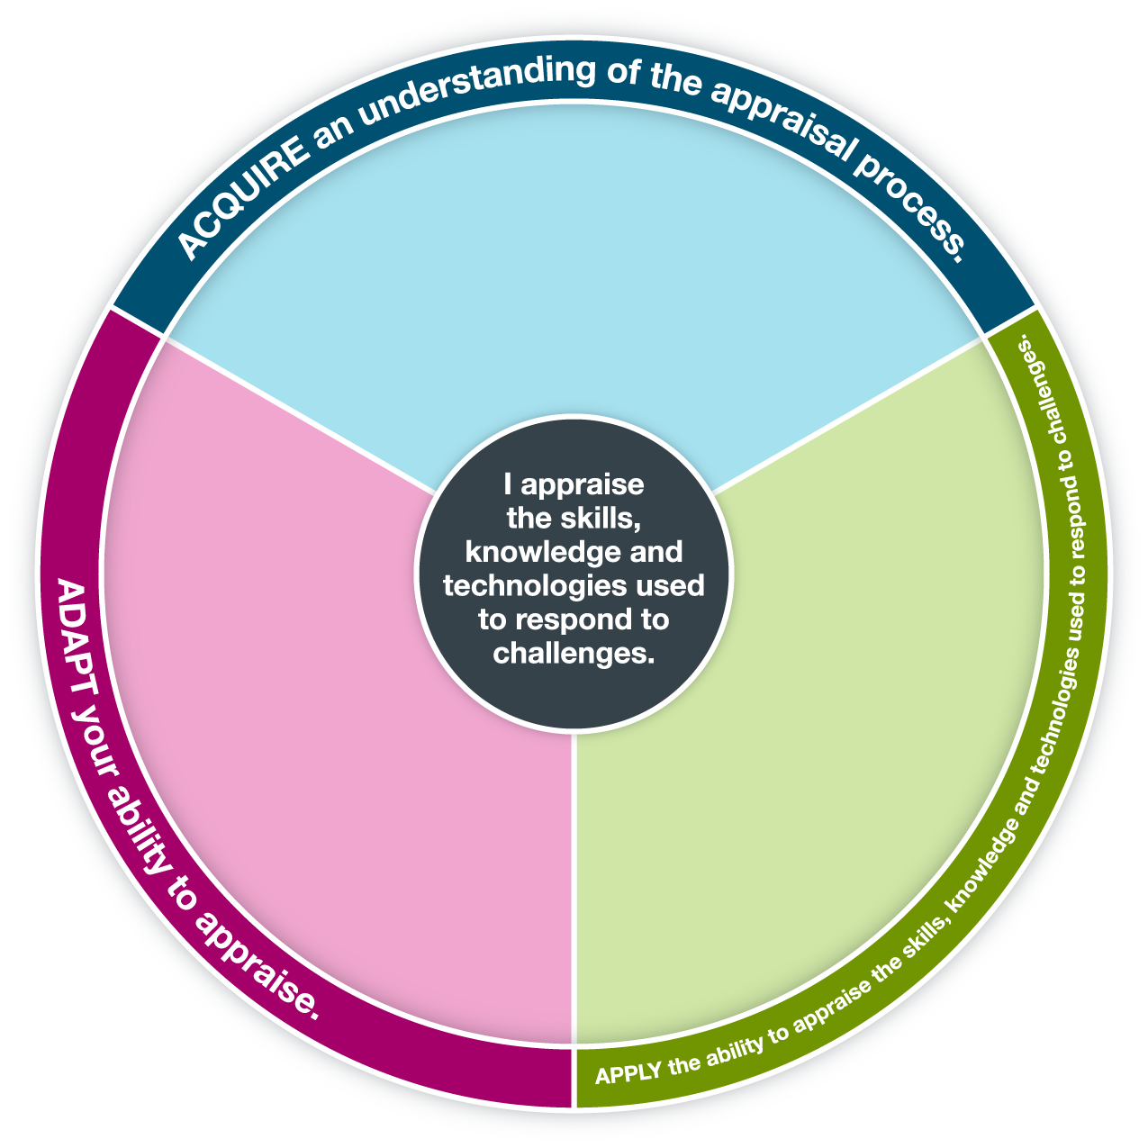
Develop your own criteria for assessing your skills, knowledge and use of technologies.
Determine the effectiveness of the appraisal feedback received during the challenge.
Appraise the skills, knowledge and technologies you use in the challenge.
Use appraisal feedback to assess your skills, knowledge and use of technologies.
Explain how you can use the information you get from an appraisal.
Explain why you appraise skills, knowledge and use of technologies.
Describe ways that you can appraise skills, knowledge and use of technologies.

You may use this pre-populated tool or customize it with your own text.

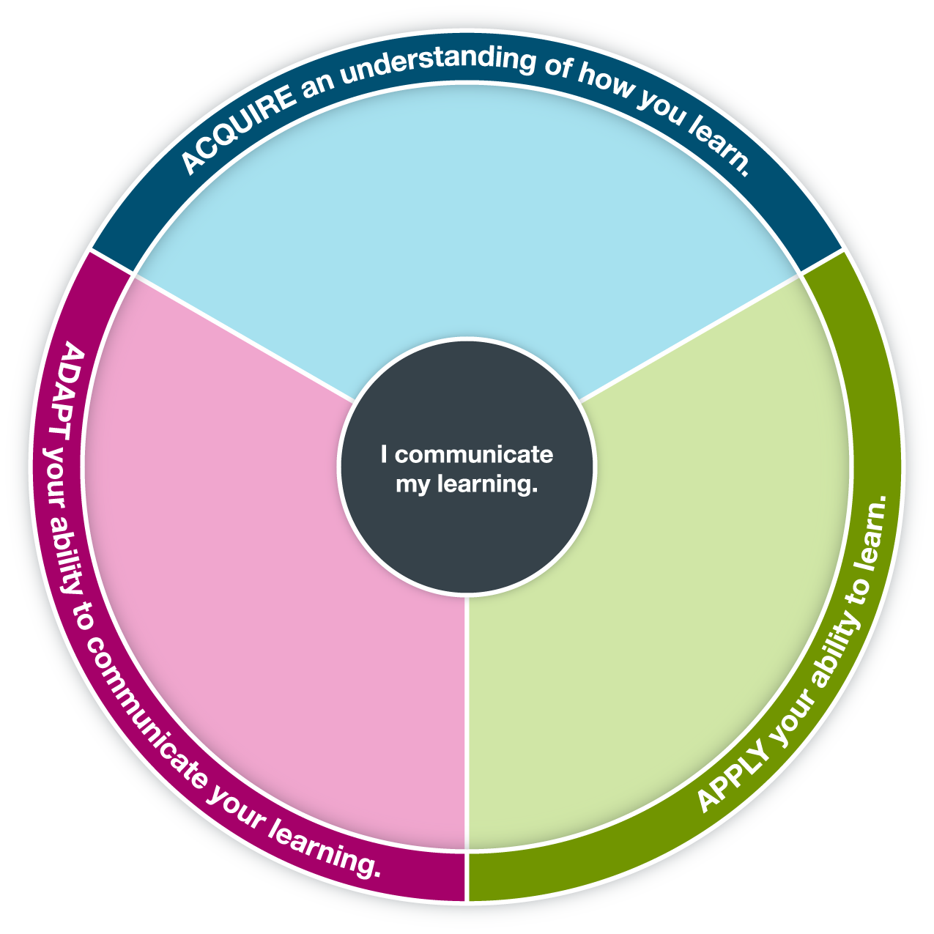
Communicate how you take risks and learn from mistakes in order to grow.
Determine the next steps required to further your learning.
Collect evidence that supports your growth as a learner.
Evaluate the effectiveness of strategies you use to learn during the challenge.
Practise strategies that help you learn during the challenge.
Identify barriers to your learning.
Explain why you might prefer one way of learning over another.
Discuss different ways that people learn.

You may use this pre-populated tool or customize it with your own text.

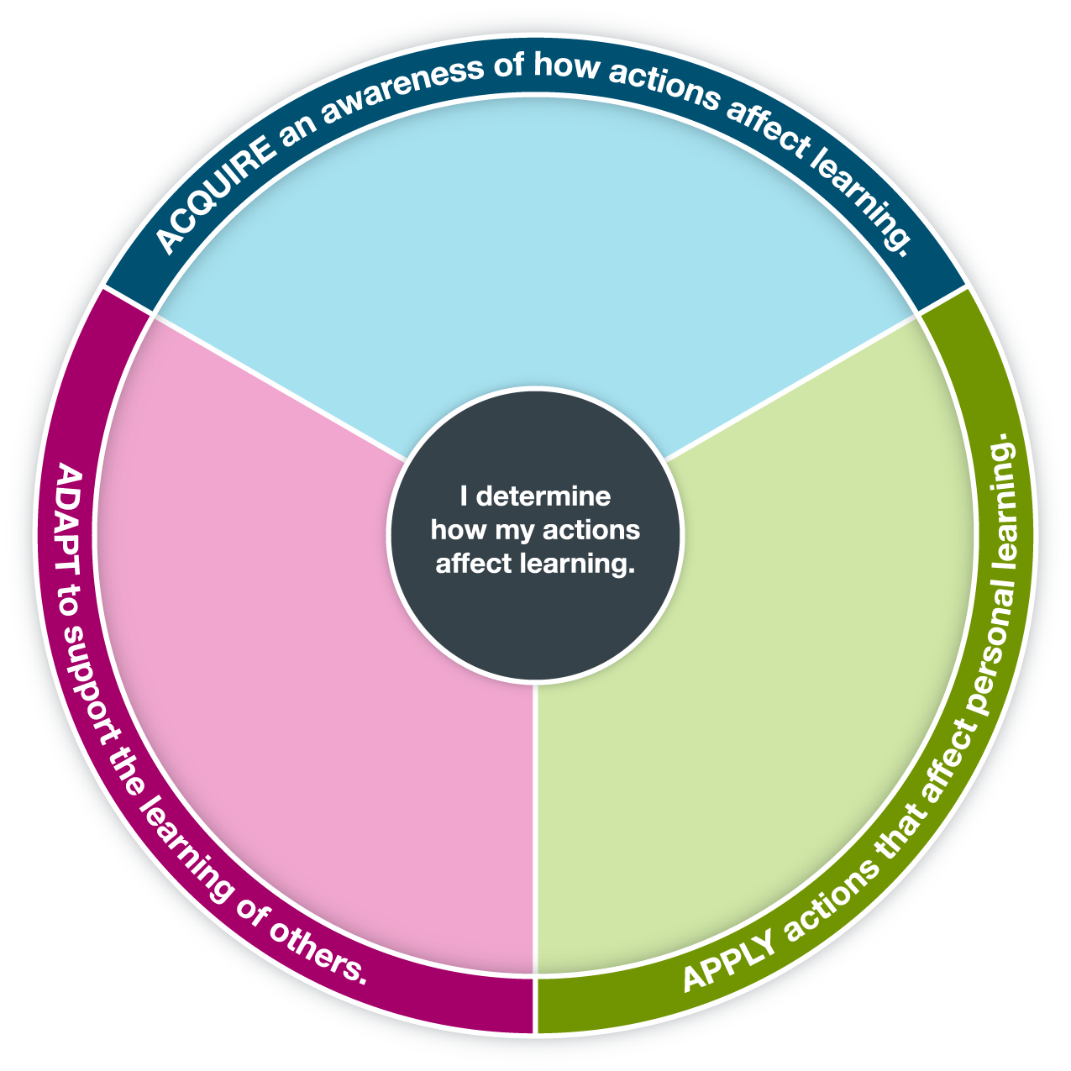
Recognize how your actions affect the learning of others.
Explain your role and responsibility in supporting the learning of others.
Promote an environment that supports learning.
Describe how students’ actions can affect learning.
Plan how you will support your learning.
Practise actions that support your learning.
Assess how your actions affect your learning.
Discuss your responsibilities as a learner.

You may use this pre-populated tool or customize it with your own text.

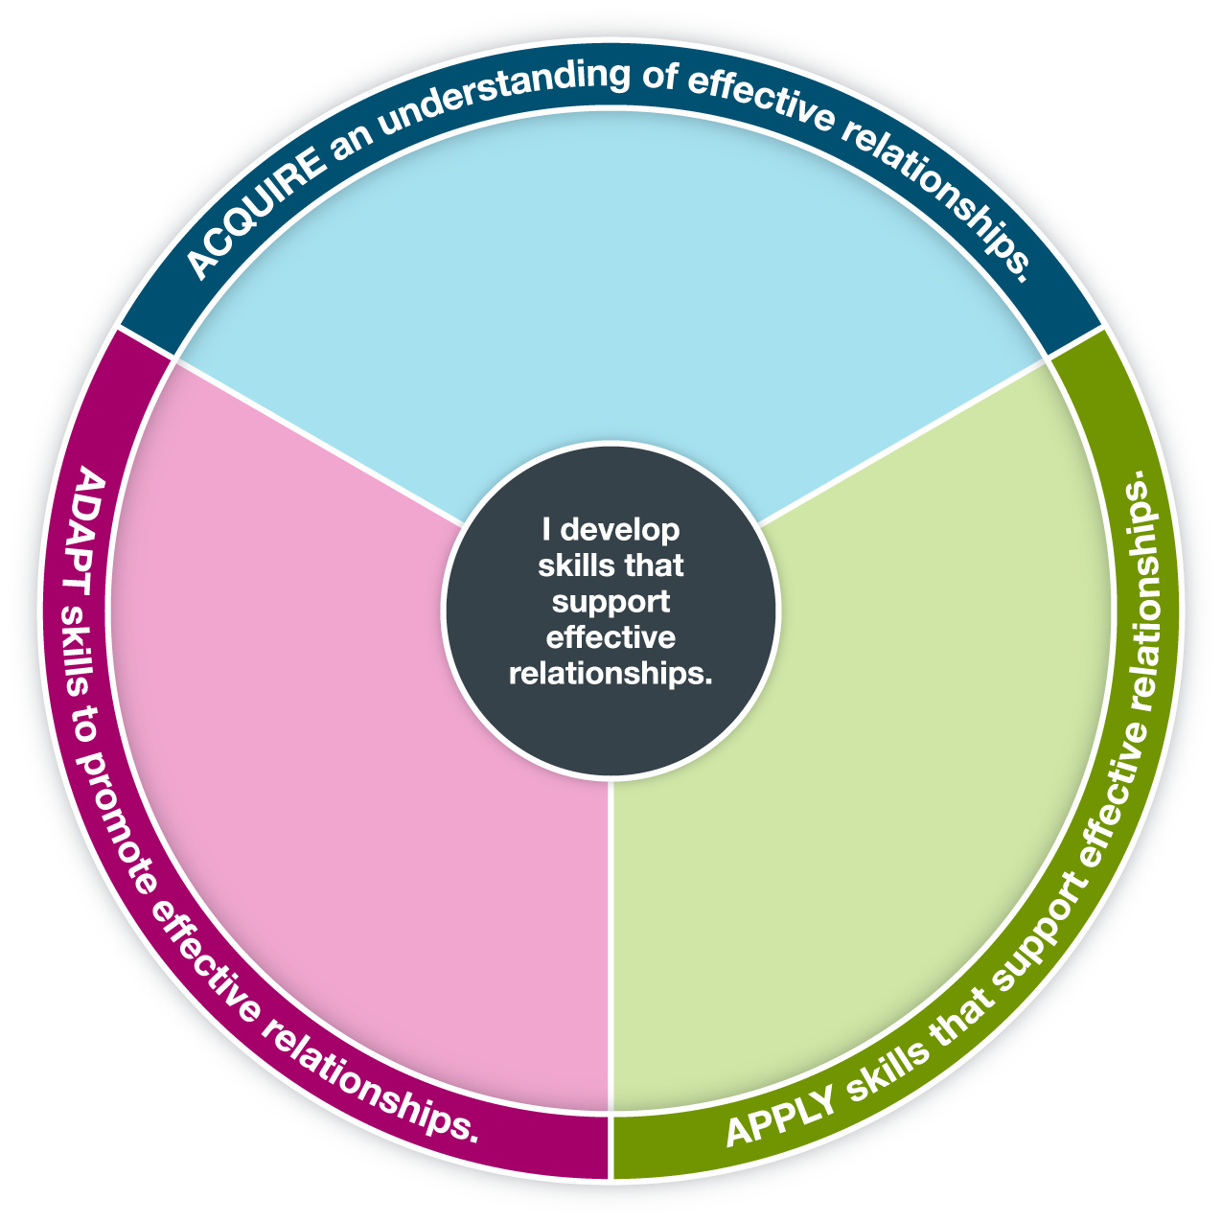
Assess the strengths and limitations of what you do to support effective relationships during the challenge.
Justify the skills you use to support effective relationships during
the challenge.
Encourage others to work toward personal goals that will help develop
effective relationships.
Mentor others in their development of effective relationship skills.
Strengthen your ability to support effective relationships.
Practise interpersonal skills that support effective relationships during
the challenge.
Identify effective relationships.
Explain what it takes to support effective relationships.
Examine what you do to support effective relationships.

You may use this pre-populated tool or customize it with your own text.

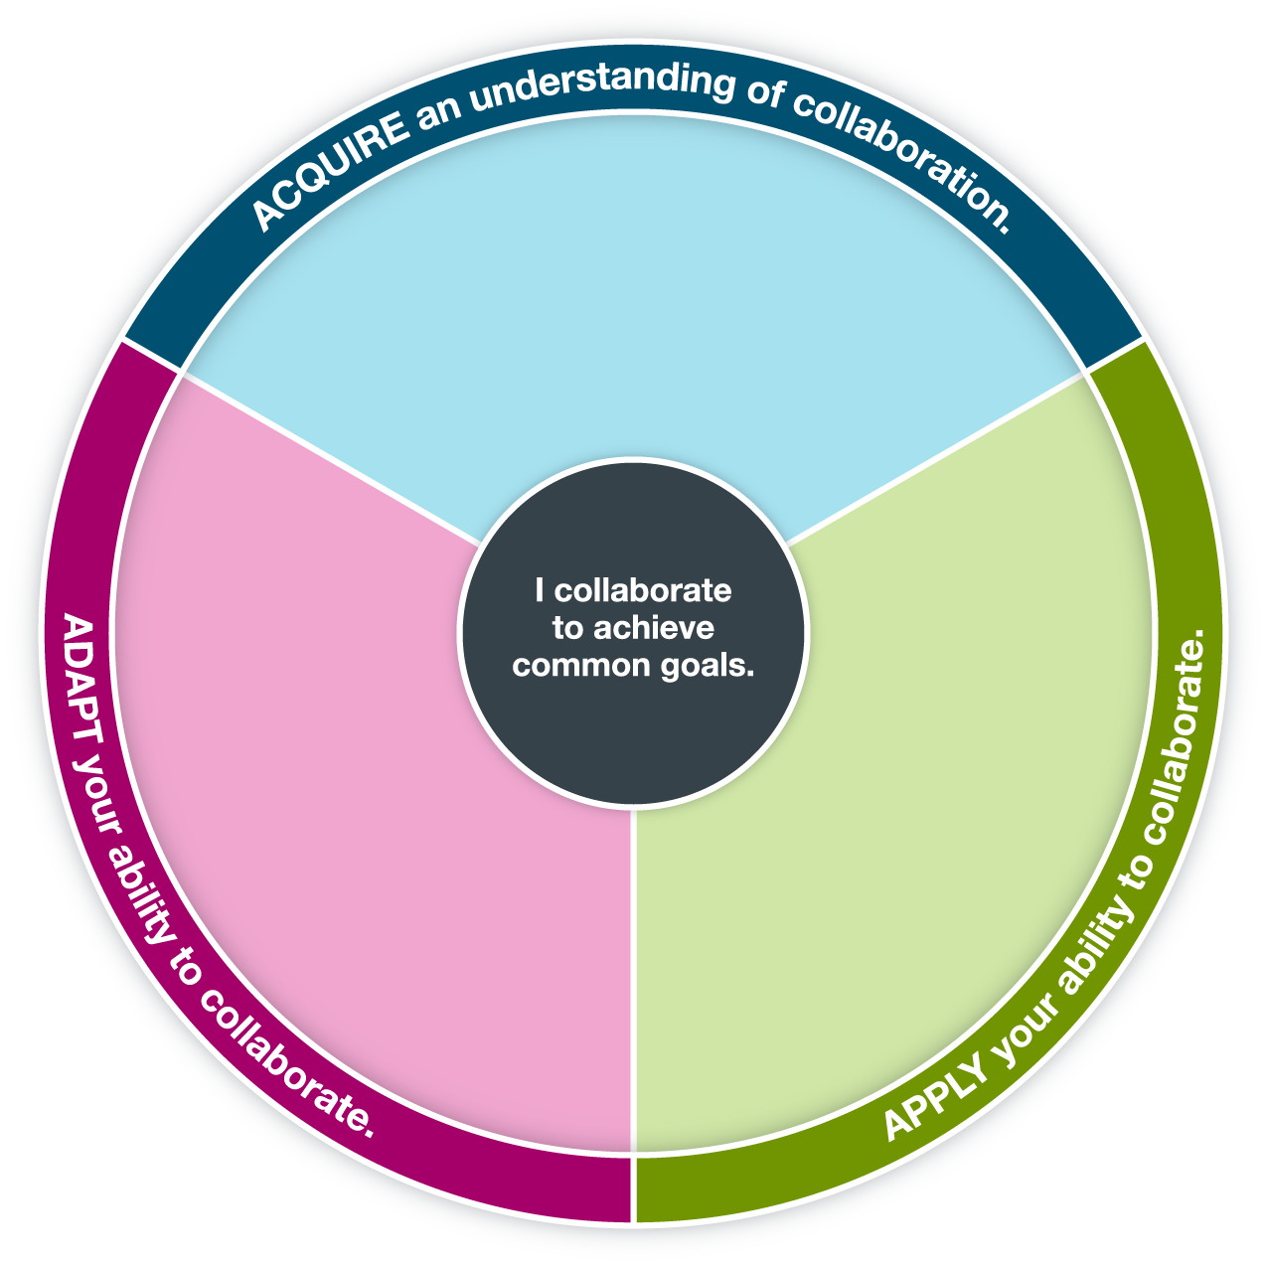
Mentor others to collaborate to achieve a common goal.
Lead or support others in working through conflict to achieve common goals.
Explain how group dynamics affect the achievement of common goals.
Describe advantages of working with others.
Provide examples of ways to work together.
Examine attitudes, behaviours or skills required for working with others.
Evaluate how your collaboration with others helps to achieve common goals.
Practise collaboration skills during the challenge.
Strengthen your ability to collaborate.

